MAIN LAP - (approx. 1.1K excl. start/finish sections) - undulating parkland (180ft max. elevation).
LARGER LAP including red loop - (approx. 1.2K excl. start/finish sections) - undulating parkland (180ft max. elevation).

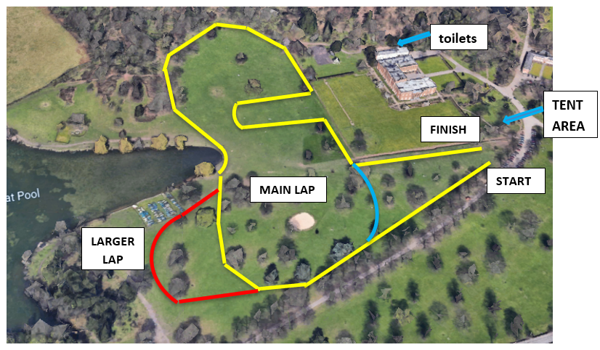
TIMETABLE OF EVENTS, DISTANCES & LAP DETAILS

10.00 U14 Girls (yr7&8) (2.6K) 2 “larger” laps (incl. red section)

10.20 U14 Boys (yr7&8) (2.6K) 2 “larger” laps (incl. red section)

10.40 U16 Girls (yr9&10) (3.5K) 3 main laps

11.00 U16 Boys (yr9&10) (3.8K) 3 “larger” laps (incl. red section)

11.20 U18 Girls (yr11&12) (3.8K) 3 “larger” laps (incl. red section)

11.40 U18 Boys (yr11&12) (4.4K) 4 main laps

